The Loudoun County, Virginia, Government and
The Ashburn American Legion Leonard W. Kidd Memorial Post 2001
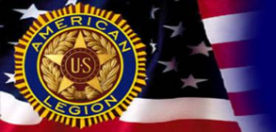
Present the 5th Annual
Loudoun Salute to Military, Veterans & Families
From 10:30 a.m. - 4:00 p.m.
Saturday, October 27, 2018
Stone Bridge High School, 43100 Hay Rd, Ashburn, VA 20147
entertainment program begins at noon
- Music by John Champe High School String Orchestra and Hillside Elementary School Choir
- Welcome from Loudoun County Board of Supervisors Chair Phyllis Randall and Vice-Chair Ralph Buona
- Presentation by Bonnie Carroll, president & founder, Tragedy Assistance Program for Survivors (TAPS)

Veterans Services Provided From 10:30 a.m. to 4:00 p.m.
- Start new VA claims or resolve existing ones.
- Sign up for your VA Benefits on the spot.
- “One Stop Shopping” – meet over 40 Veteran Services and Information Providers!
Service Officers from The American Legion and other VSOs will help you and your families.
some of our sponsors, partners and programs
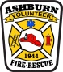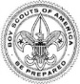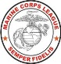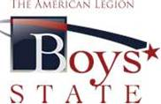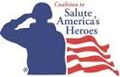

Dulles Cosmetic Surgery and Skin Care Center, PLLC, David Berman, M.D.

Help us help our Veterans and their families!
To donate, visit our website at ashburnlegion.org, or mail check to PO Box 1243, Ashburn, VA 20146. Thank you!

